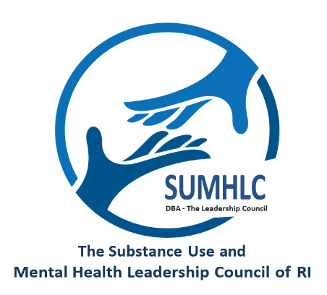 MEMBERSHIP APPLICATION

Thank you for your interest in becoming a member of The Substance Use and Mental Health Leadership Council of RI (d/b/a The Leadership Council). Membership is open to any Rhode Island-based organization licensed by the Rhode Island Department of Behavioral Healthcare, Development Disabilities and Hospitals. Other organizations or firms offering goods and services to the behavioral health industry are welcome to apply to become Associate Members.

GENERAL INFORMATION

Date:
Organization: Click or tap here to enter text.
Name: Click or tap here to enter text. Title: Click or tap here to enter text.
Address: Click or tap here to enter text.
City: Click or tap here to enter text. State: Click or tap here to enter text.
Zip: Click or tap here to enter text.

Contact Information of Person Completing Application (if different than above):
Name: Click or tap here to enter text.
Title: Click or tap here to enter text.

Phone: Click or tap here to enter text. Ext: Click or tap here to enter text.
Fax: Click or tap here to enter text.
Primary email: Click or tap here to enter text.
Website: Click or tap here to enter text.

How did you become aware of The Leadership Council? Click or tap here to enter text.

ORGANIZATIONAL INFORMATION

Is your organization licensed in Rhode Island to provide the following services? (Check all that apply)

☐ Behavioral Healthcare Services (mental health and/or substance use disorder treatment)
☐ Health, Education, Other Human Services
☐ Not Licensed
☐ Other

Is your Organization licensed by: (Check all that apply)
☐ BHDDH
☐ DCYF
☐ DOH
☐ RIDE
☐ Other (Please specify) Click or tap here to enter text.

Is your Organization accredited by a nationally recognized accrediting body (i.e., The Join Commission, CARF, COA, NCQA, etc.) ☐ Yes ☐ No

If yes, please specify: Click or tap here to enter text.

Please attach the Organization’s Mission Statement and/or By-Laws:

The population you serve can be described as (need, ages, etc.): Click or tap here to enter text.
Number of individuals served during most recent fiscal year: Click or tap here to enter text.
Number of Full-Time Employees: Click or tap here to enter text.
Number of Part-Time Employees: Click or tap here to enter text.
What is the geographic area served by the organization (town, city, county)? Click or tap here to enter text.

Is the organization incorporated as a Rhode Island non-profit? ☐ Yes ☐ No ☐ Pending

Is the organization tax-exempt as a 501C3? ☐ Yes ☐ No ☐ Pending

What is your organization’s total of all behavioral health and substance use revenue derived within Rhode Island excluding inpatient hospital revenue (level 4/hospital based per DOH determination) for the most recent fiscal
year $

Please attach revenue documentation. Acceptable forms of documentation include: an affidavit from the President/CEO and CFO, IRS Form 990 (pages 1-2), Audit Report and/or Financial Statement for the most current fiscal year (or calendar year).

MEMBERSHIP
How will membership in The Leadership Council benefit your Organization? Click or tap here to enter text.

How will membership in The Leadership Council strengthen the network of our membership? (Membership list is attached).

All organizations seeking full membership in The Leadership Council must agree to become a member in good standing with the National Council for Behavioral Health. For more information on the National Council, please visit its website at www.thenationalcouncil.org

I understand and agree to become a member of the National Council for Behavioral Health. (Please initial). Click or tap here to enter text.

COMMUNICATIONS PREFERENCES

Email: In addition to membership information, the email addresses provided will receive timely information about news, workshops, trainings, events, advocacy issues, and other items of interest to members.
Email addresses are not shared with third parties.

☐ Add those listed below to this email list.
Click or tap here to enter text.

Please email application to:
Sophia H. Elanani
The Substance Use and Mental Health Leadership Council of RI
15 Messenger Dr, First Floor. Warwick, RI 02888
Tel: 401-521-5759 Cell 401-572-1257
selanani@sumhlc.org

Upon submission of your completed application, The Leadership Council’s Governance Committee will review it and if approved, it will be presented to the Board of Directors. Please note: The Board considers each request for membership separately to ensure that the mission and values of The Leadership Council are consistent with those of the organizations seeking membership.

The Substance Use and Mental Health Leadership Council of RI is a Rhode Island non-profit corporation.

